1. **Title of the project:FOREST FIRES**

**Introduction**

Python is the most popular programming language used for Machine Learning and Artificial Intelligence.

Machine Learning and Artificial Intelligence requires continuous data processing, and Python’s libraries let you access, handle and transform data. These are some of the most widespread libraries you can use for ML and AI:

1.Scikit-learn 2.Pandas 3.Keras etc.

1. Python for Machine learning and Artificial Intelligence is a great choice, as this language is very flexible:
2. It offers an option to choose either to use OOPs or scripting.
3. There’s also no need to recompile the source code, developers can implement any changes and quickly see the results.
4. Programmers can combine Python and other languages to reach their goals.
   1. **Objectives of Research**

The overall **objective** of the project is to control and reduce the role of the **forest fires** as natural hazard for the Alpine environment considerably through prevention and mitigation actions. Currently **forest fires** play a major role in threatening the **forest** heritage of the Alps.

* 1. **Problem Statement**

**Problems:**

The world has two **problems** with **fire**: an increase in unwanted **fires** and a parallel reduction in necessary **fires**. Each year **fires** affect huge areas of **forest**, grasslands and scrub that would not burn under natural circumstances.

**Solutions:**

Be certain to completely extinguish cigarettes before disposing of them. Follow local ordinances when burning yard waste. Avoid backyard burning in windy conditions, and keep a shovel, water, and **fire** retardant nearby to keep **fires** in check. Remove all flammables from yard when burning.

**2.Review of literature**

**1)linear regression**

**2)svm**

Besides these machine learning techniques, the project also explores different ways to represent the data as shown in the exploratory data analysis section.

**3. Data Collection:**

* the dataset we are working have wind,rain,rh,month,day,ffmc,dmc,dc.output is area.It explains how much area is affected with all those inputs.

**4. Methodology**

**Exploratory Data Analysis**

**Figues and Tables**

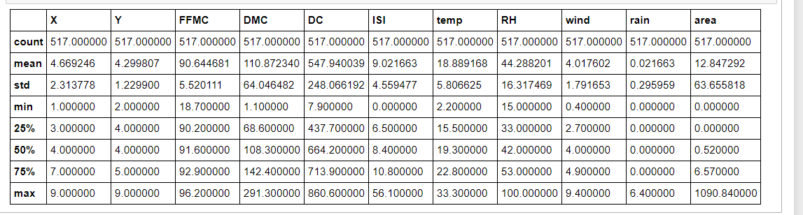

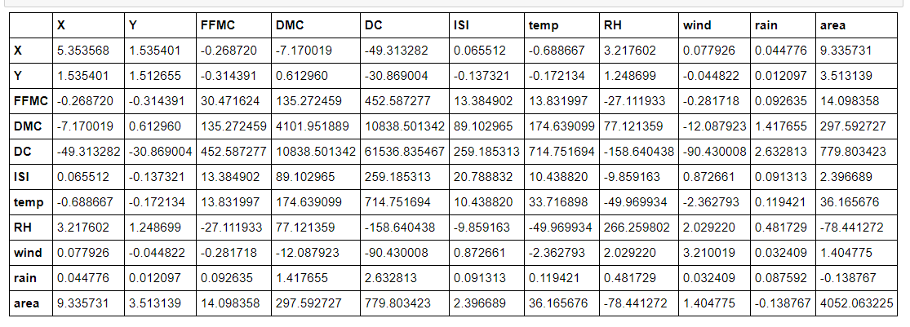

**4.2 Data Modelling**

This section should contain information about Algorithms applied to the model and its Implementation

**5. Findings and Suggestions**

This section should contain the information about various sources, updations, and suggestions about project

**6.Conclusion**

Forest fires have an immediate effect on mortality, not associated with accidental deaths, which is a significant public health problem, especially if the fire occurs near a densely populated area.This model clearly explains how much area is affected and its adverse effects.